DOM Parser

🌳 What is a DOM Parser?
# Source: AI Source: Provided by: [Data Path: Persons Table -> ID Column: 1, Name_En Column: Motasem Essam] -> From: [Chatgpt (GPT‑5 Mini)] on [12/9/2025]
A DOM Parser (Document Object Model Parser) is a type of XML or HTML parser that reads an entire document and loads it into memory as a tree structure, called the DOM tree.

🔹 Key Concept:
# Source: AI Source: Provided by: [Data Path: Persons Table -> ID Column: 1, Name_En Column: Motasem Essam] -> From: [Chatgpt (GPT‑5 Mini)] on [12/9/2025]
A DOM parser converts XML or HTML into a tree of nodes, where each node represents an element, attribute, or piece of text.
Once the tree is built, you can navigate, modify, or query the document just like working with a structured object.

📄 Example XML:
# Source: AI Source: Provided by: [Data Path: Persons Table -> ID Column: 1, Name_En Column: Motasem Essam] -> From: [Chatgpt (GPT‑5 Mini)] on [12/9/2025]
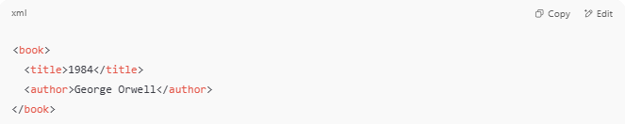
<book>
<title>1984</title>
<author>George Orwell</author>
</book>

A DOM parser will load this into a memory structure like:
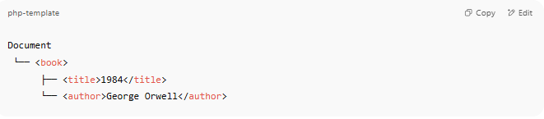
Document
└── <book>
├── <title>1984</title>
└── <author>George Orwell</author>

🔧 How It Works
# Source: AI Source: Provided by: [Data Path: Persons Table -> ID Column: 1, Name_En Column: Motasem Essam] -> From: [Chatgpt (GPT‑5 Mini)] on [12/9/2025]
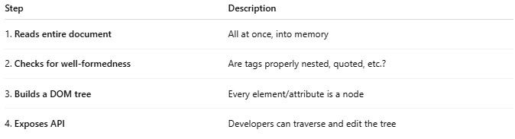
Step | Description
1. Reads entire document | All at once, into memory
2. Checks for well-formedness | Are tags properly nested, quoted, etc.?
3. Builds a DOM tree | Every element/attribute is a node
4. Exposes API | Developers can traverse and edit the tree

🧰 DOM Parser Examples (by Language)
# Source: AI Source: Provided by: [Data Path: Persons Table -> ID Column: 1, Name_En Column: Motasem Essam] -> From: [Chatgpt (GPT‑5 Mini)] on [12/9/2025]
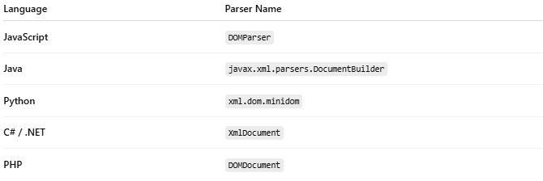

Language | Parser Name
JavaScript | DOMParser
Java | javax.xml.parsers.DocumentBuilder
Python | xml.dom.minidom
C# / .NET | XmlDocument
PHP | DOMDocument

💡 Example in JavaScript:
# Source: AI Source: Provided by: [Data Path: Persons Table -> ID Column: 1, Name_En Column: Motasem Essam] -> From: [Chatgpt (GPT‑5 Mini)] on [12/9/2025]
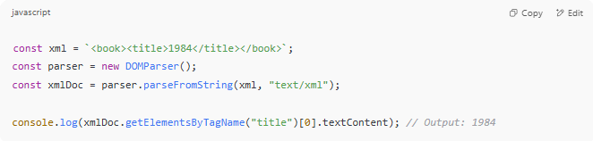
const xml = `<book><title>1984</title></book>`;
const parser = new DOMParser();
const xmlDoc = parser.parseFromString(xml, "text/xml");

console.log(xmlDoc.getElementsByTagName("title")[0].textContent); // Output: 1984

✅ Advantages of DOM Parser
# Source: AI Source: Provided by: [Data Path: Persons Table -> ID Column: 1, Name_En Column: Motasem Essam] -> From: [Chatgpt (GPT‑5 Mini)] on [12/9/2025]
- Easy to navigate (getElementById, getElementsByTagName, etc.)
- Allows full read/write access to document
- Ideal for small to medium XML documents

❌ Disadvantages
# Source: AI Source: Provided by: [Data Path: Persons Table -> ID Column: 1, Name_En Column: Motasem Essam] -> From: [Chatgpt (GPT‑5 Mini)] on [12/9/2025]
- Loads entire document into memory → not suitable for large files
- Slower for very large XML
- High memory usage compared to stream-based parsers like SAX or StAX

🔁 DOM vs SAX Parser (Quick Comparison)
# Source: AI Source: Provided by: [Data Path: Persons Table -> ID Column: 1, Name_En Column: Motasem Essam] -> From: [Chatgpt (GPT‑5 Mini)] on [12/9/2025]
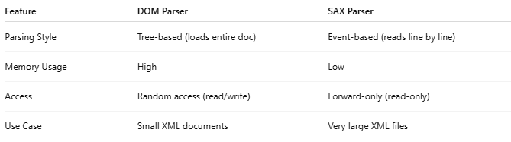
Feature | DOM Parser | SAX Parser
Parsing Style | Tree-based (loads entire doc) | Event-based (reads line by line)
Memory Usage | High | Low
Access | Random access (read/write) | Forward-only (read-only)
Use Case | Small XML documents | Very large XML files

📌 Summary
# Source: AI Source: Provided by: [Data Path: Persons Table -> ID Column: 1, Name_En Column: Motasem Essam] -> From: [Chatgpt (GPT‑5 Mini)] on [12/9/2025]
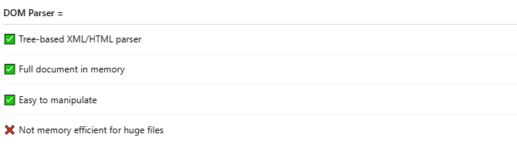
DOM Parser =
✅ Tree-based XML/HTML parser
✅ Full document in memory
✅ Easy to manipulate
❌ Not memory efficient for huge files

